AEM Training - Day 5 Assignment (24-03-2025)

# Implementation Guide

## Creating News Articles

Description:

We will create structured **News Articles** in AEM under a dedicated section.

Steps:

* 1. Navigate to **/content/us/en/news** in AEM.
  2. Create five unique **news pages** with:

 **Headline** (h2)

 Article Content (p)

 Publication Date

# Screenshots

1. 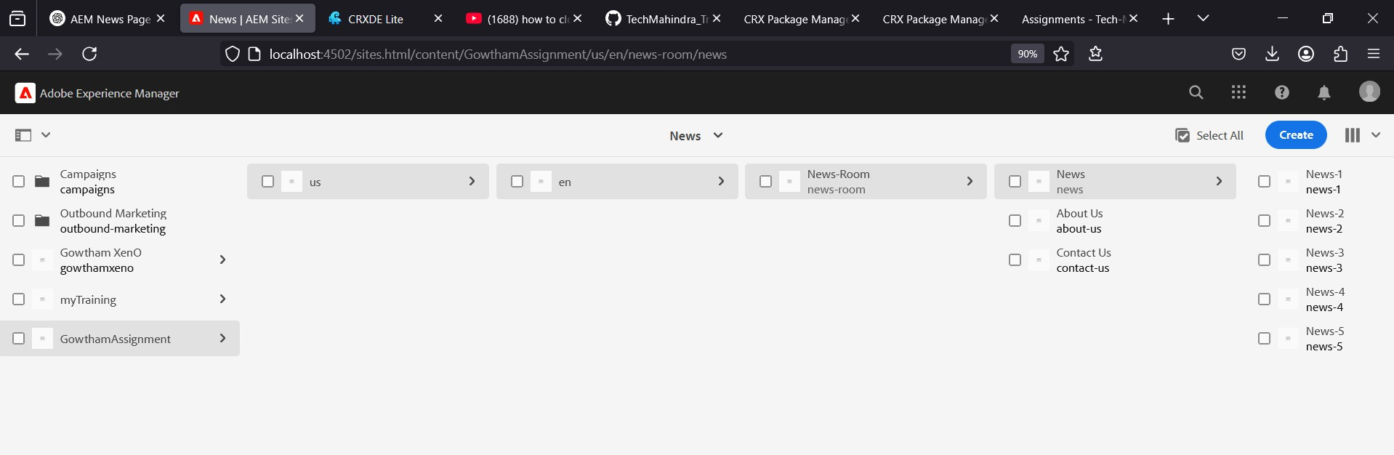**News Pages**

## Adding the News Component

Description:

The **News Component** will display news articles dynamically.

Steps:

* 1. Use the **existing News Component** to render articles.
  2. Ensure it includes:

 **Headline** (<h2>) with distinct styling.

 **News Content** (<p>) for article details.

 **Publication Date** with proper formatting.

* 1. Maintain a **responsive and visually appealing design**.

Code Snippet (NewsComponent.html):

<div class="news-item">

<h2>${newsModel.headline}</h2>

<p>${newsModel.content}</p>

<span>${newsModel.publicationDate}</span>

</div>

# Screenshots

1. 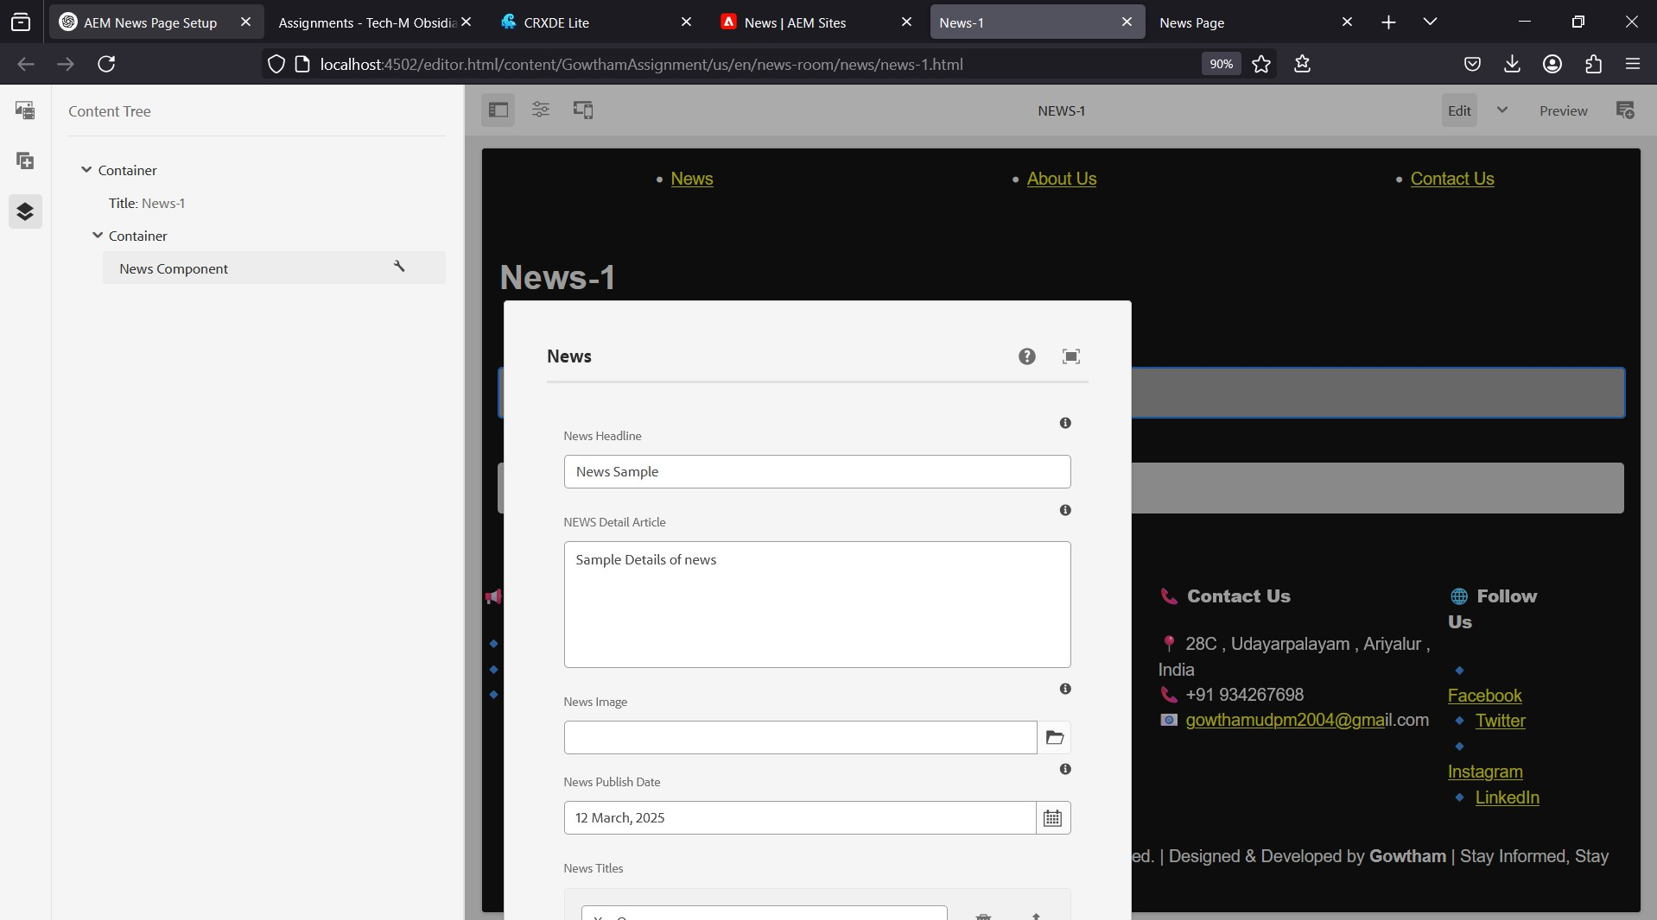**News Component**

## Setting Up the Header

Description:

A **Header Experience Fragment** will be created for seamless navigation.

Steps:

* 1. Create a **Header Fragment**.
  2. Include navigation links to:

 **News Section** (linking to news pages)

 **About Me** page

 **Contact Us** page

# Screenshots

1. 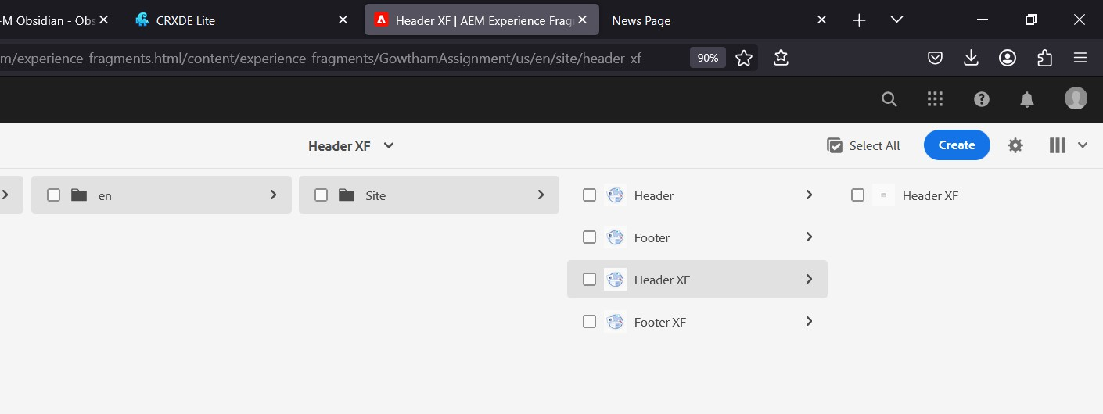**Experience Fragments**
2. **Header XF**

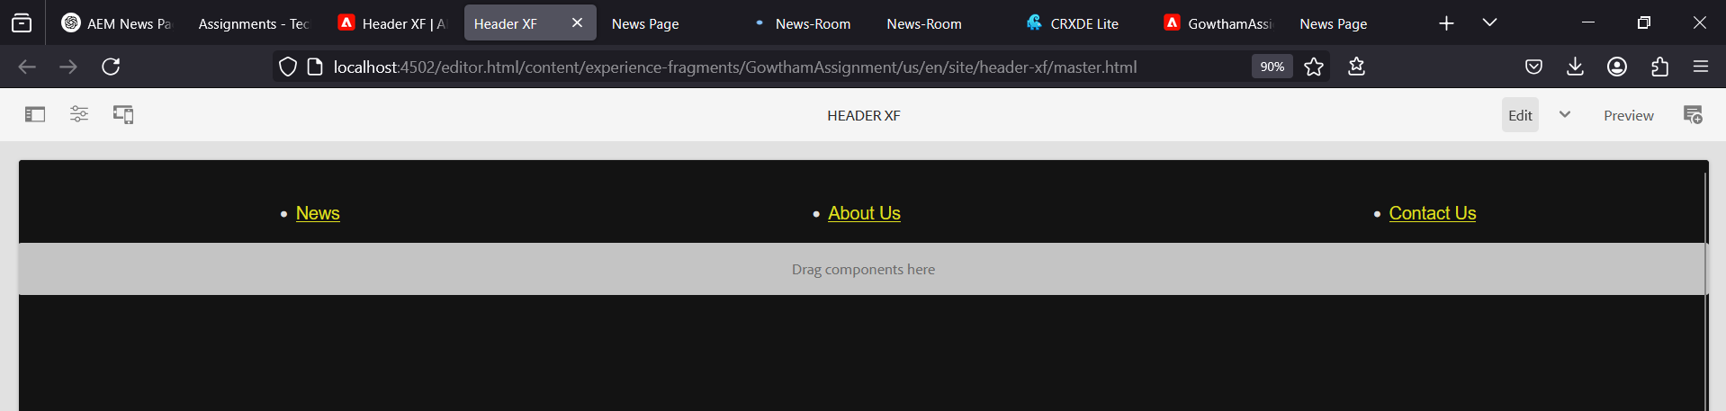

## Configuring the Footer

Description:

A **Footer Experience Fragment** will be configured with multiple sections.

Sections:

* 1. **Latest News Section**:

 Use a **List Component** to display recent news articles.

* 1. **About Me Section**:

 Add a **Text Component** with journalist details.

* 1. **Contact Section**:

 Include office address, phone number, or email.

* 1. **Social Media Section**:

 Use a **List Component** for social media links.

# Screenshots

1. 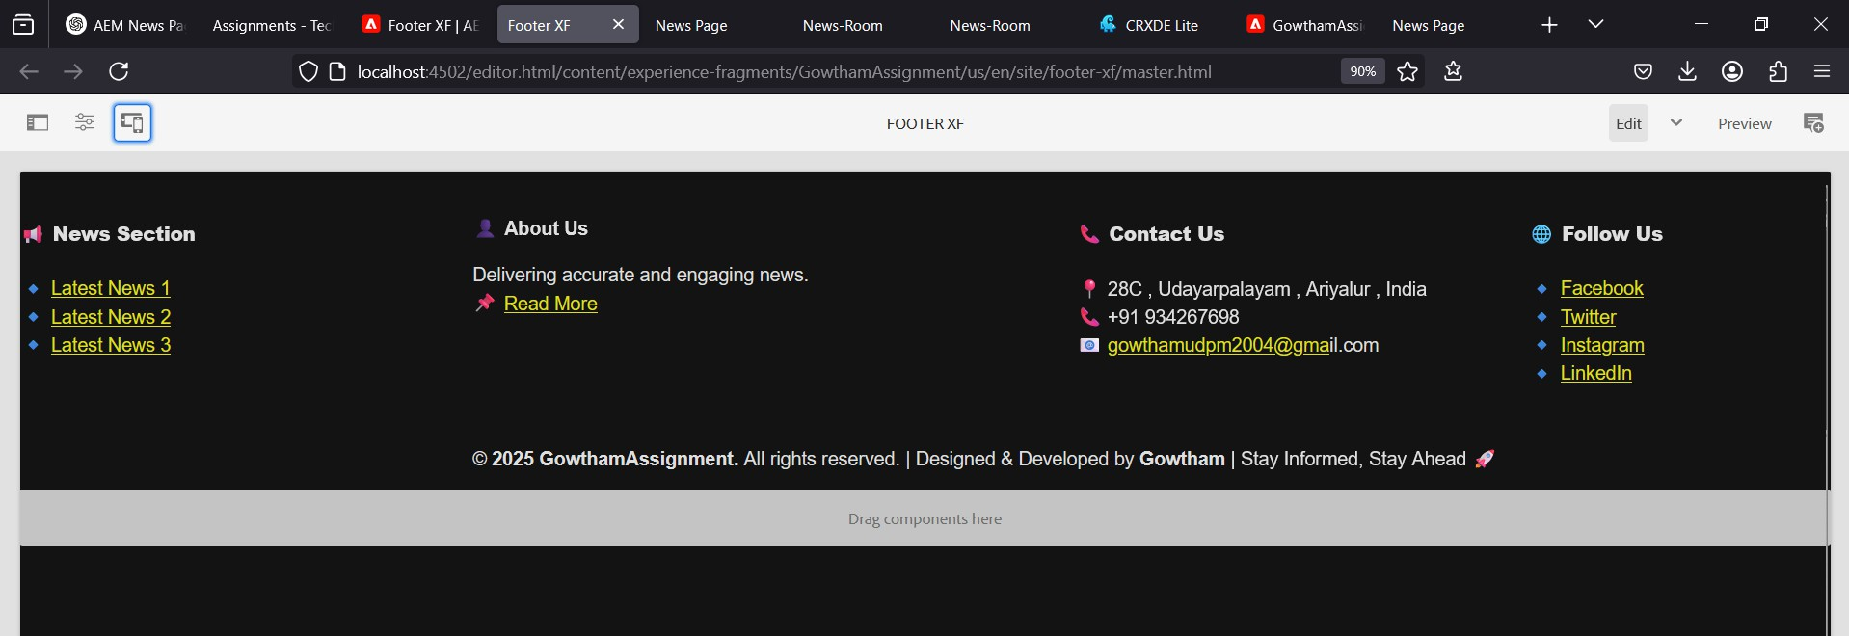**Footer XF**

## Developing a Custom Service

Description:

A **Custom OSGi Service** will be developed to return a simple response.

Steps:

* 1. Create an OSGi service class in **Java**.
  2. Inject it into the **News Component’s Sling Model**.
  3. Log the service output in AEM logs.

Code Snippet (HelloWorldService.java):

@Designate(ocd = HelloWorldConfig.class) @Component(service = HelloWorldInt.class) public class HelloWorldService {

public String getMessage() {

return "Hello World from Custom Service";

}

}

# Screenshots

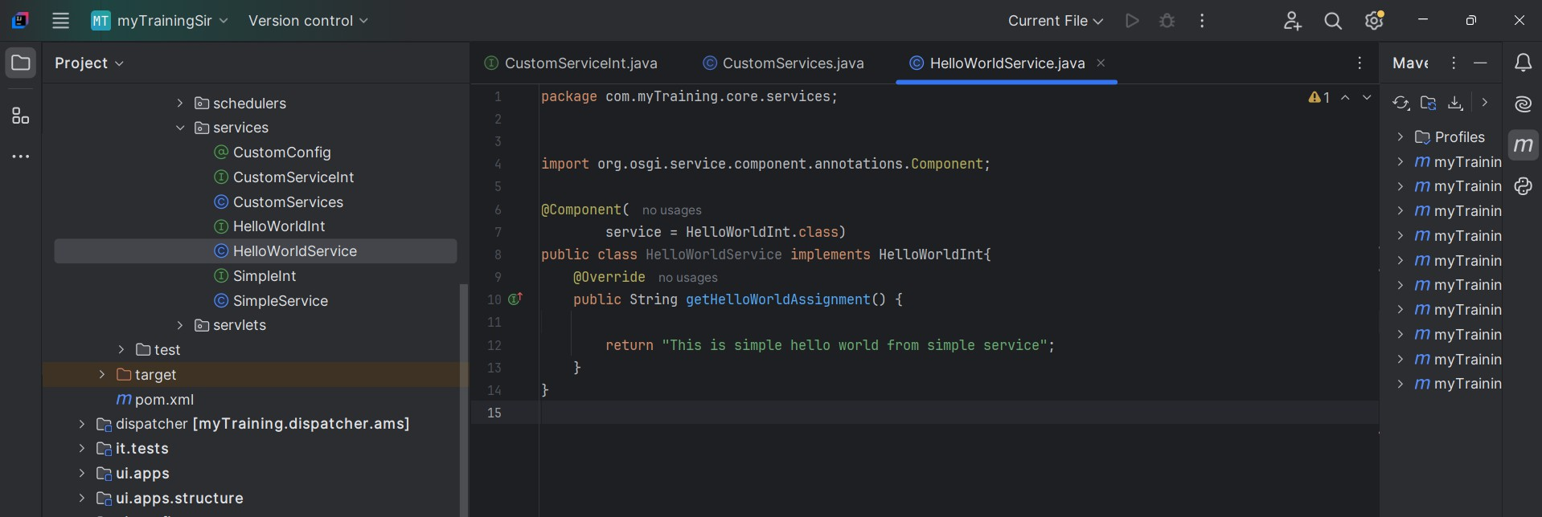**Service**

## Implementing API Configuration

Description:

We will develop a configuration to **store third-party API URLs** and fetch data.

Steps:

* 1. Define an OSGi configuration for API URLs.
  2. Fetch JSON data from a sample API.
  3. Log the response in AEM logs.

Example API:

https://jsonplaceholder.typicode.com/posts

## Adding Screenshots for About Me and Contact Us Pages

Description:

Allocate space for screenshots of the **About Me** and **Contact Us** pages.

# Screenshots

* 1. 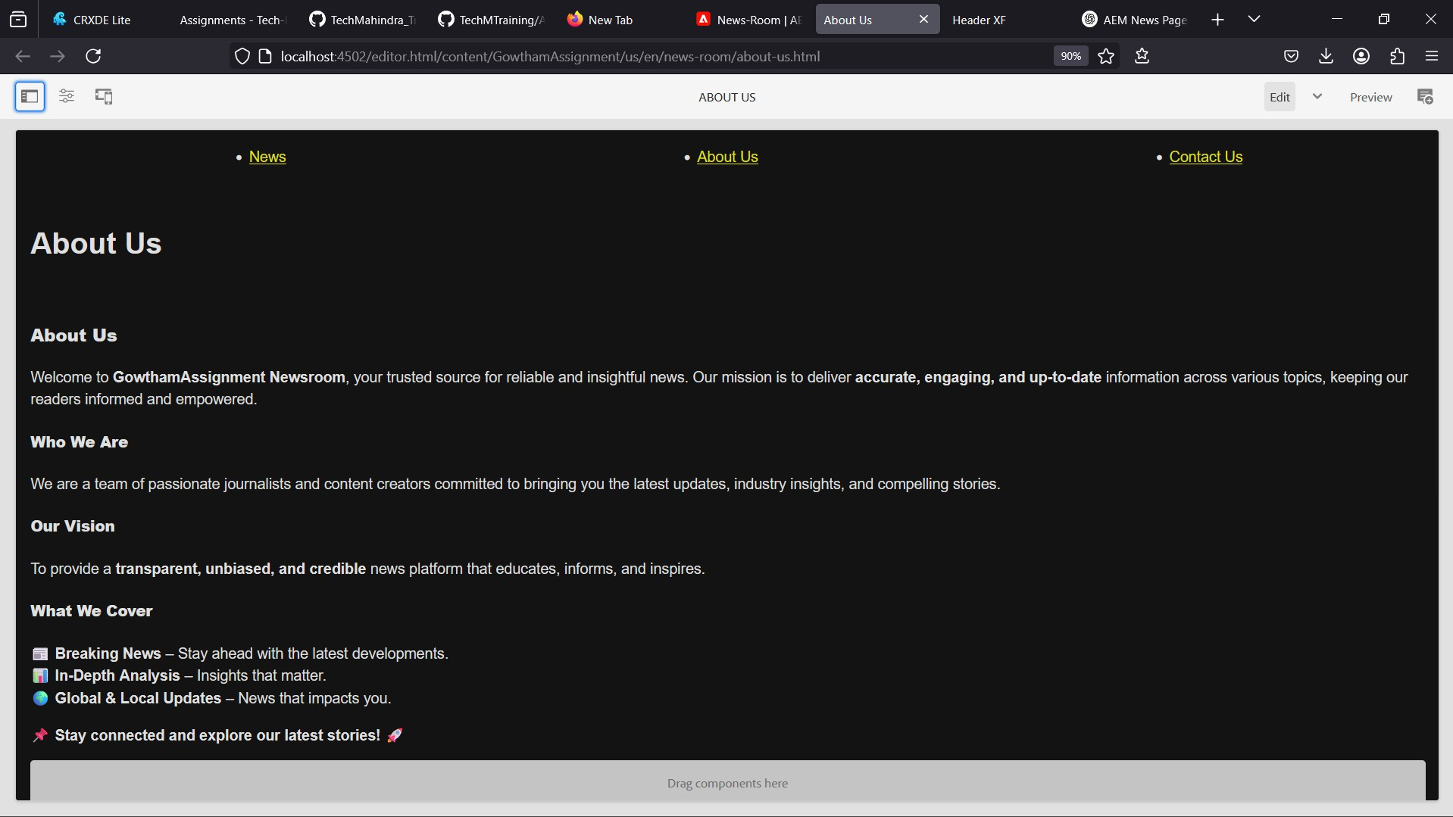**About Me Page**
  2. **Contact Us Page**

